1.Data exploration:
Field | Type | Description | Example
transaction_id | string | Unique transaction reference | TX98231
customer_id | string (hashed) | Pseudonymised payer identifier | C_7f31a9
transaction_amount | decimal (₹) | Value of the transaction | 50000.00
merchant_category | categorical | MCC group (travel, gaming, electronics, etc.) | electronics
transaction_time | timestamp (IST) | Date and time of the authorisation request | 2025-11-14 03:12:44
device_id | string (hashed) | Fingerprint of the device used | D_44be20
customer_age | integer (years) | Payer's age from KYC | 27
customer_location | lat/long + city | Location of the payer at transaction time | Pune
merchant_location | lat/long + city | Registered location of the merchant | Delhi
previous_transactions | integer | Count of the payer's transactions in the last 30 days | 14
average_transaction_value | decimal (₹) | Payer's mean transaction value over 90 days | 2,350.00
failed_transactions | integer | Failed attempts by the payer in the last 24 hours | 4
account_age | integer (days) | Days since the payer's account was created | 6
fraud_label | binary (0/1) | 1 = confirmed fraud, 0 = genuine | 1

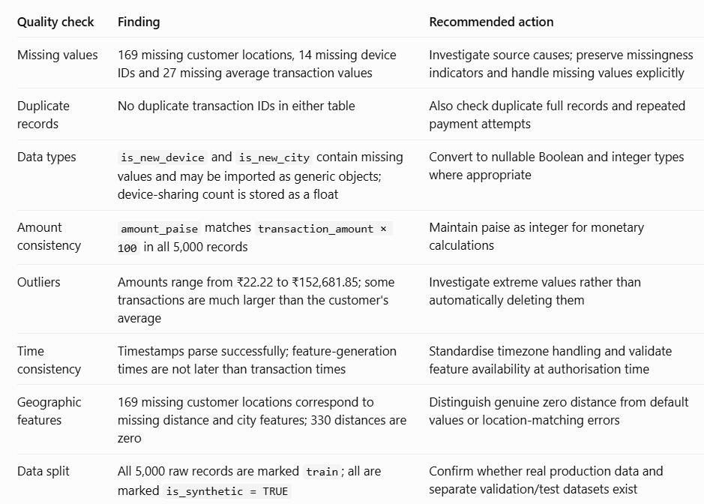

2. Why would a real organisation collect this data?
- Reduce financial losses: Detect suspicious payments before authorisation.
- Protect genuine customers: Reduce unnecessary transaction declines and false positives.
- Meet compliance requirements: Maintain evidence for investigations and audits.
- Understand fraud patterns: Identify suspicious devices, merchants, payment channels and geographic activity.
- Improve decisions: Apply risk-based actions such as approve, step-up authentication, manual review or decline.

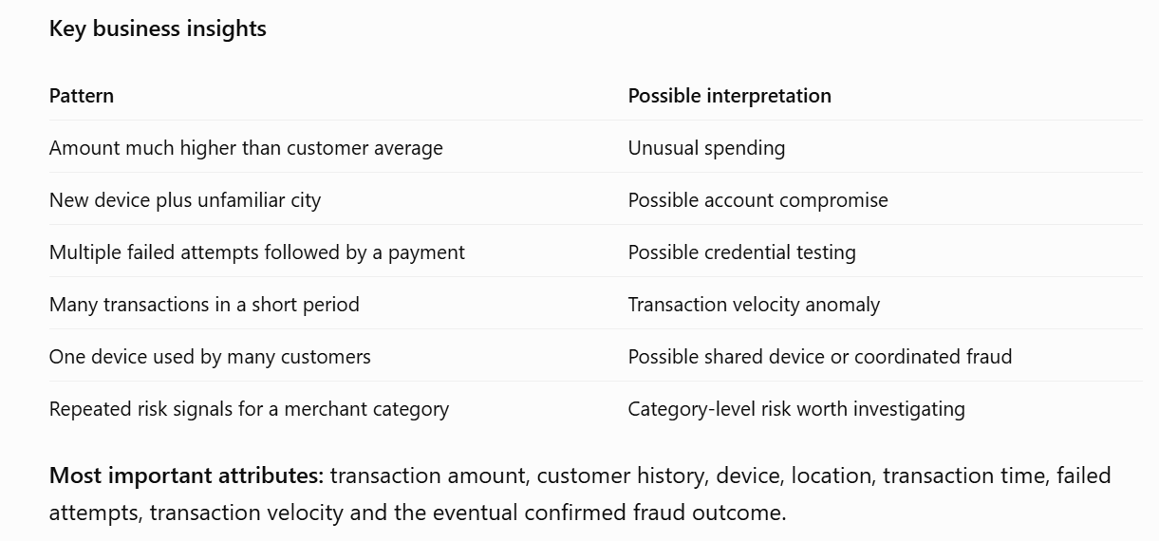

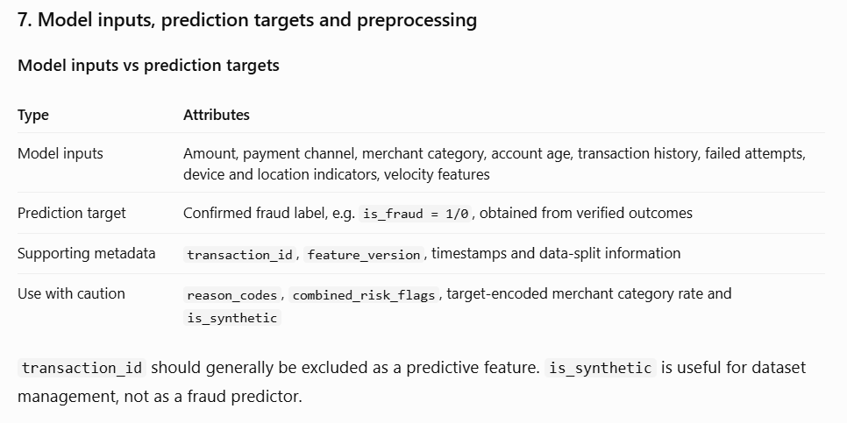

Preprocessing steps:
1. Handle missing values and standardise Boolean, numeric, categorical and timestamp types
2. Remove duplicate or redundant features where appropriate
3. Split data chronologically and evaluate on unseen transactions.
4. Address class imbalance and evaluate precision, recall, fraud value captured, false-positive rate and precision-recall AUC.

Feature engineering opportunities:
- Spending ratio: transaction amount divided by the customer's historical average.
- Velocity: transaction counts and total spending over 5-minute, 1-hour and 24-hour windows.
- Geographic risk: distance from usual customer locations and physically implausible travel between transactions.
- Device risk: device age, number of linked customers and recent device changes.
- Behavioural deviation: difference between current activity and the customer's historical patterns.
- Combined signals: interactions between new devices, high amounts and repeated failures.
